**Refog Keylogger**

**Introduction:**

REFOG Keylogger is keylogger software that monitors websites and applications.

the keylogger software keeps track of what each user is typing, which sites are being visited, what software are being used, and what images are being viewed. All of this information is recorded by the undetected program that runs 24/7. With comprehensive reports on each user's activities.

All the data is organized and stored on an online dashboard so you can view it at your convenience.

The purpose of the application :Ensure Your Child’s Safety

Concerned about your child’s safety when they use the internet? REFOG Keylogger can help. This security application is designed to help parents monitor their kids’ online activities. It alerts the users about the suspicious activities of either your children or someone they chat with. The app is easy to set up and use and does not involve a steep learning curve for you to configure and operate it. Once launched, you can set up a list of all activities that you wish for the app to log. These include recording all visited websites, logs of chats and instant messenger conversations, and other things that your children types or received, such as online and offline applications. As with other keyloggers, REFOG Keylogger captures each keystroke typed in the computer, allowing you to monitor what your children type as they chat. For even better protection, you can configure the app to run silently and unobtrusively so that it will be completely hidden from your kids’ eyes. Using this app, you can ensure your child safety every time they go online.

**Application Security**

According to REFOG’s privacy policy, they will not share or sell your personal data with any third party organization. All data that is collected through the keylogger and webcam are encrypted and stored on a secure server to prevent hackers and other cybercriminals from getting your personal information. It’s important that you only [**download REFOG from its official site**](https://www.wizcase.com/?1cb29f090eb94b3ae18b662be0bed58c=MjI1NzEzfA==&vid=225713&target=ShortCodeAffiliateLink_225713_product_8804209&platform=desktop&pageview_id=2|LAZGN8U8QB896&clickout_id=2|LAZGN8U8QB896|1|225713) and not a third-party download website. The problem with third-party sites is that bad actors can add malware to the installer to access your private data.

1. **Installing:**
2. [**Go directly to the official REFOG website**](https://www.wizcase.com/?1cb29f090eb94b3ae18b662be0bed58c=MjI1NzEzfA==&vid=225713&target=ShortCodeAffiliateLink_225713_product_8804213&platform=desktop&pageview_id=2|LAZFW3GLTZF4K&clickout_id=2|LAZFW3GLTZF4K|1|225713) and press the Download button.

Website link: <https://www.refog.com/free-keylogger.html>

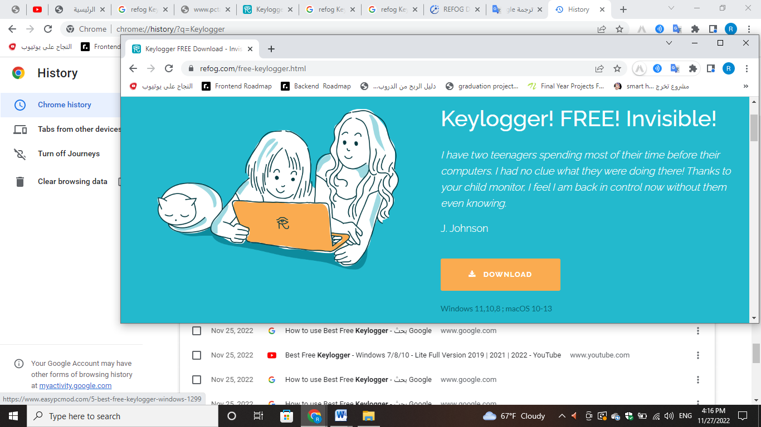

1. Enter a valid email address, password, and check the box to agree to the terms to create your REFOG account.
2. Click on the Download button under the Personal Monitor for Windows box.

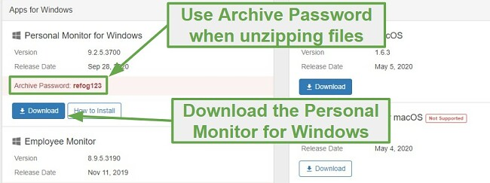

IMPORTANT: If you have an antivirus program running, you will need to turn it off temporarily, or it will block the REFOG installation.

1. Unzip the folder using a program like Winzip or WinRAR
2. Open the .exe file that was unzipped, and the installation wizard will open.
3. Select whose computer you’ll be monitoring, your child’s, employee’s, or your own, and click Next.
4. Agree to the End User License Agreement.
5. Select what actions REFOG should monitor and record and then click Next.

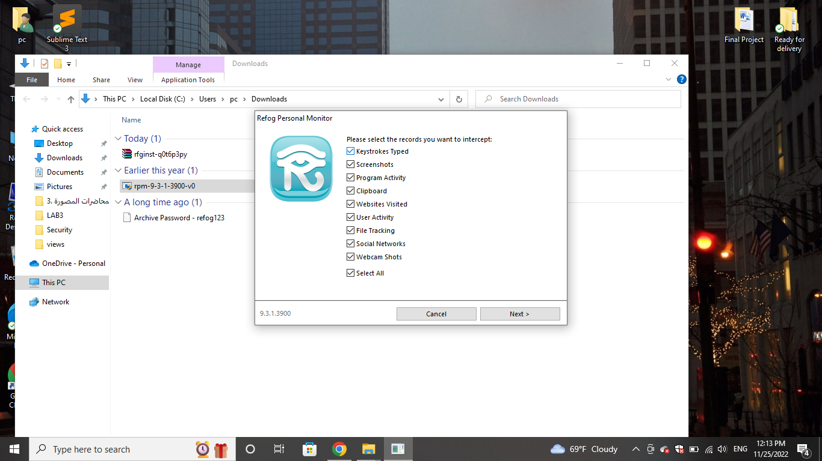

1. Unzip the folder using a program like Winzip or WinRAR
2. Open the .exe file that was unzipped, and the installation wizard will open.
3. Select whose computer you’ll be monitoring, your child’s, employee’s, or your own, and click Next.
4. Agree to the End User License Agreement.
5. Select what actions REFOG should monitor and record and then click Next.

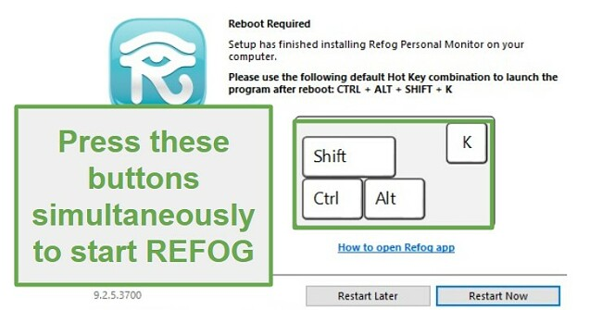

* **The below screenshot provides a detailed comparison of the features offered by Refog Personal Monitor and Refog Employee Monitor.**

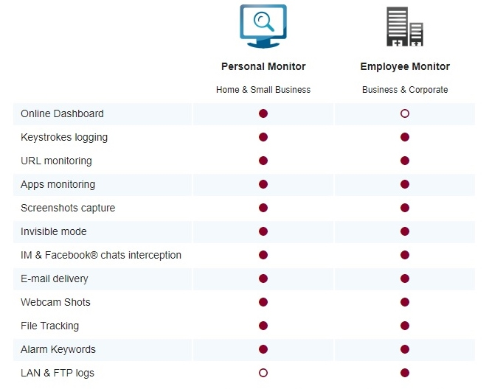

1. **Disable & Uninstall**

Since REFOG is a monitoring program that runs in the background, you will have to disable it before you can uninstall it. Follow these steps to disable and uninstall REFOG:

1. Log in to your REFOG dashboard.
2. If you have REFOG running on multiple devices, click on the Devices button on the menu and select the device you wish to disable.
3. On the bottom of the sidebar is the Setting icon. Click it to open the setting menu.
4. Choose the Delete Device option.

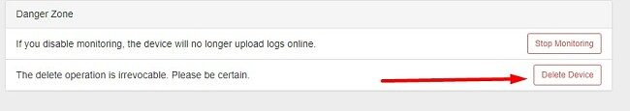

1. Confirm that you want to delete REFOG.
2. Go to the device that you’re monitoring with REFOG and hold the Shift + CTRL + ALT + K keys together to open the software.
3. Click on the Buy Later link to access the dashboard.

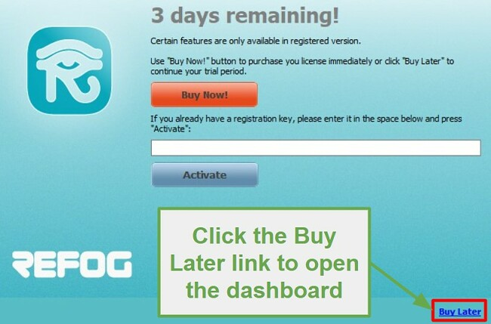

1. Click on the Tools tab on the menu button and then choose Uninstall.

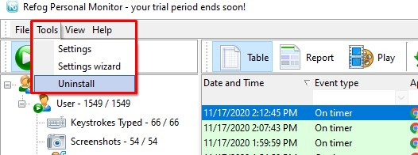

1. Confirm that you want to delete the program, and it will be completely uninstalled from the device.
2. **Application Interface**

This report option presents the selected logs as a detailed report that you are seeing now

Stop the monitoring process

Start monitoring your pc

**10**

**9**

**8**

**7**

**6**

Stop the monitoring process

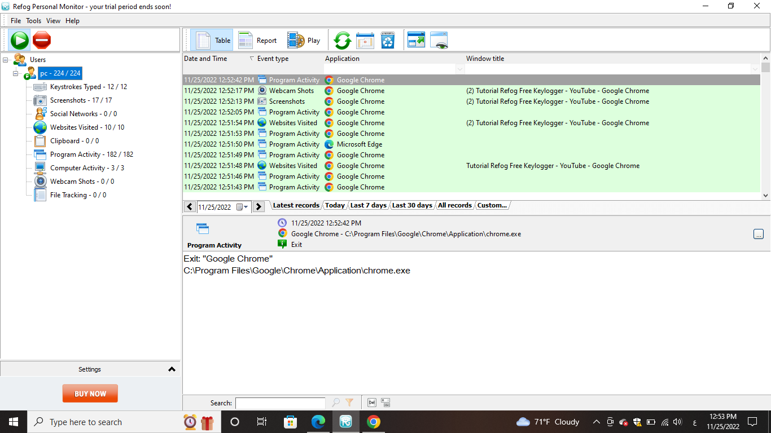

Maximises the application window to full screen mode

Clears all the captured logs

Different activities that are captured and recorded during the monitoring process for the logged in user.

Refreshes all the logs

Presents the captured logs as a slideshow with pause, fwd and rewind options

Select a date range to view the logs for that date range

**5**

**4**

**3**

**2**

**1**

1. The big green button and red button present at the top left corner of the window allows you to start and stop the monitoring process of your PC.
2. In the left side of the application window, you can see the list of user logins and different activities that are captured for each user. In the below screenshot, you can see that for a particular user, a number of keyboard strokes, screenshots, websites visited and many more details are captured.

You can click on each of the activity to view all the logs captured for that particular activity on the right side of the application window.

1. Clicking on the table button at the top of the window will display the logs as a simple table.
2. The report button will display all the logs for the selected date range as a detailed report in PDF format which you can download and save it on your PC.

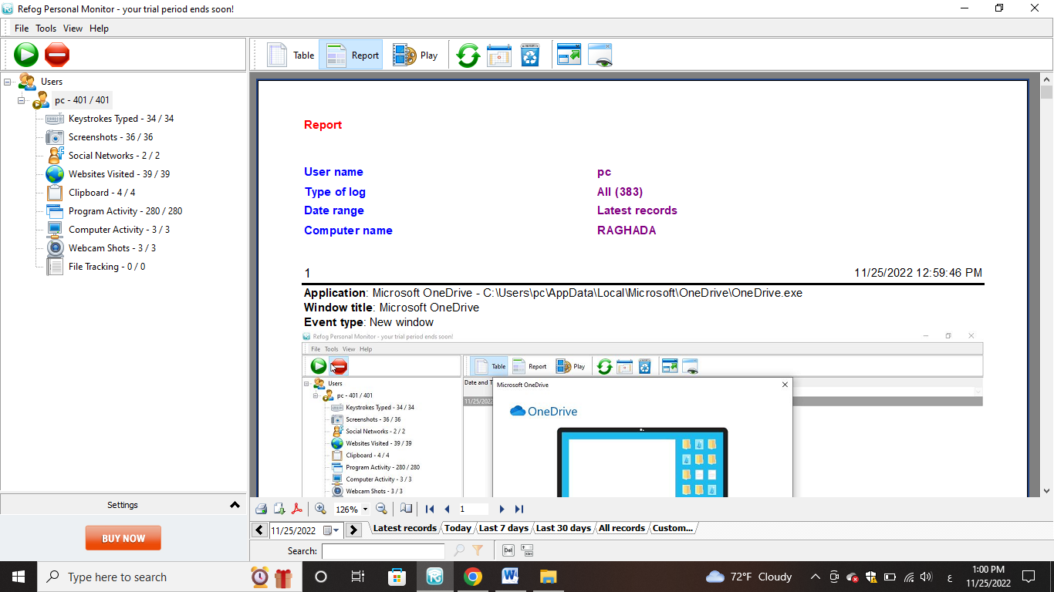

Click here to save this report as a PDF file

Click here to save this report as a PDF file

You can download it as a PDF file or take a print out of it by using the options present at the bottom

1. The play button when clicked will start a slideshow of all the captured records and activities that are present in the table.
2. The refresh button will refresh all the details.
3. The date filter button allows you to select a particular date range for which you wish to view the captured activities.

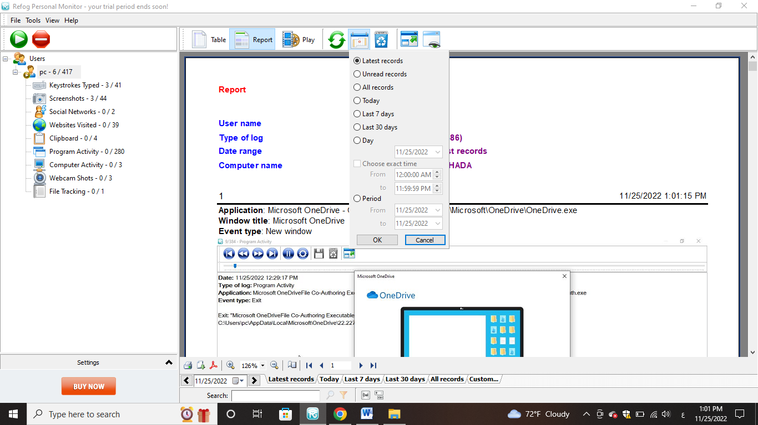

1. Clear logs button will clear all the captured records on your PC.

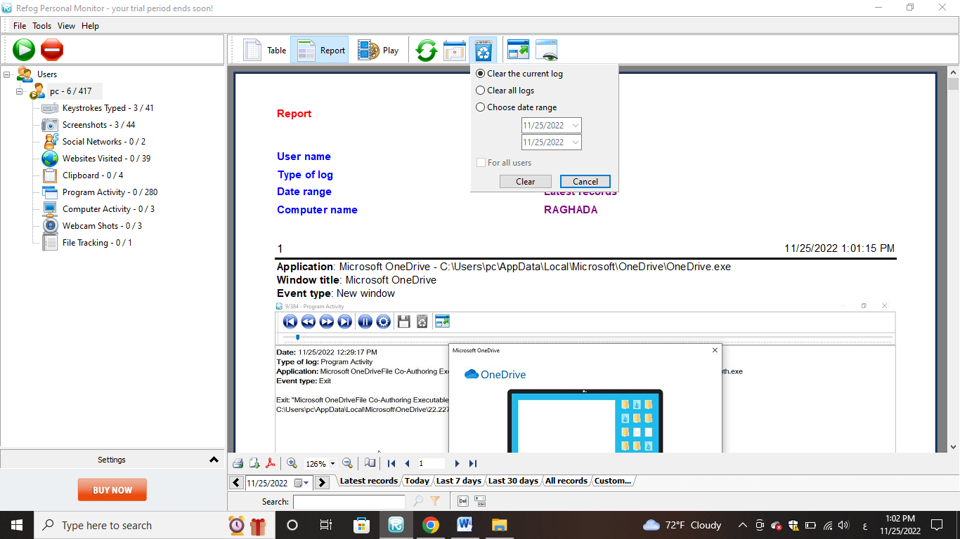

1. unhide icon, you can enter a secret key combination to open the hidden refog keylogger app and see all keystrokes and passwords.
2. **Help**: For any help on how to use the software, then you can access their online tutorial or help manual by clicking the online FAQ button under the help button at the top.
3. **Features offered by the application**

Let’s take a look at some of the features, the software offers its users.

1. **Keystroke recording** feature can effectively capture all the keyboard entries made your children on your PC. It can record all the text like username, password, messages typed by your children on your PC.

Displays all the keystrokes entered by the user during the monitoring process

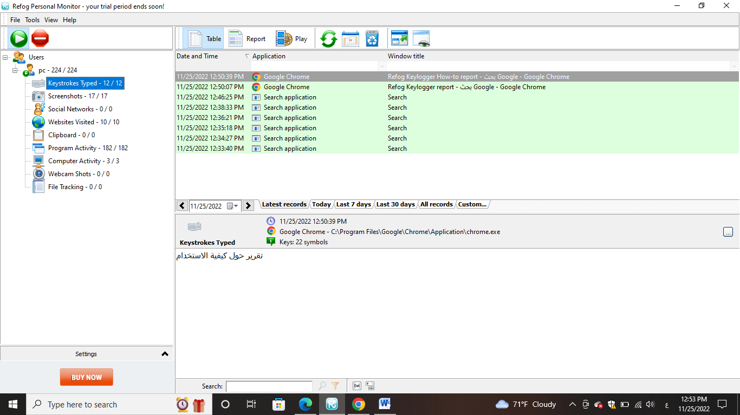

1. **Screenshot capturing** feature of the software takes a screenshot of your desktop screen at regular intervals of time when the user is using your PC. So you can visually come to know what the user or children are doing on your PC.

Displays all the screenshots captured whenever user switches over to a different screen. Click on a particular screenshot to open it in the below window

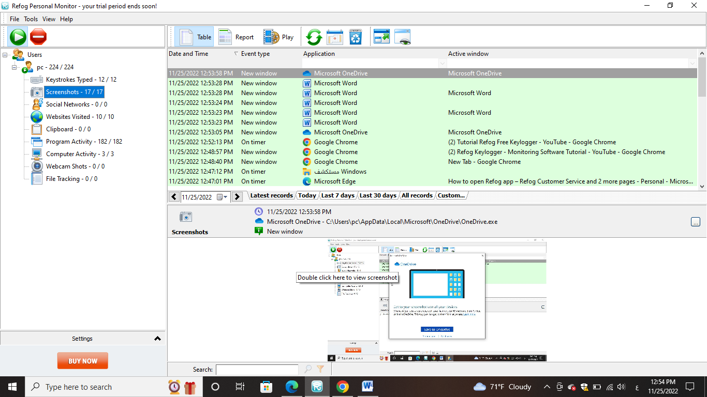

This is the screenshot selected by you in the upper window. Double click on it to view as a full size image

Use these options to select a date range and list down the activities captured in that date range

1. **Social Networks** REFOG has a social media monitoring feature that tracks Facebook, WhatsApp, Viber, and Telegram…etc.

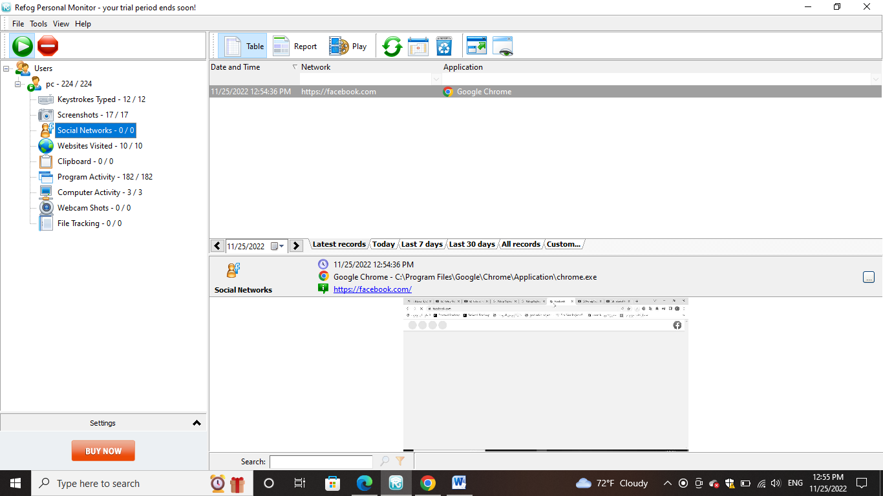

1. **Website monitoring** feature can effectively track all the websites and webpages visited by your children. The software keeps track of all the websites visited along with their timestamp even after the browsing history is deleted by the user.

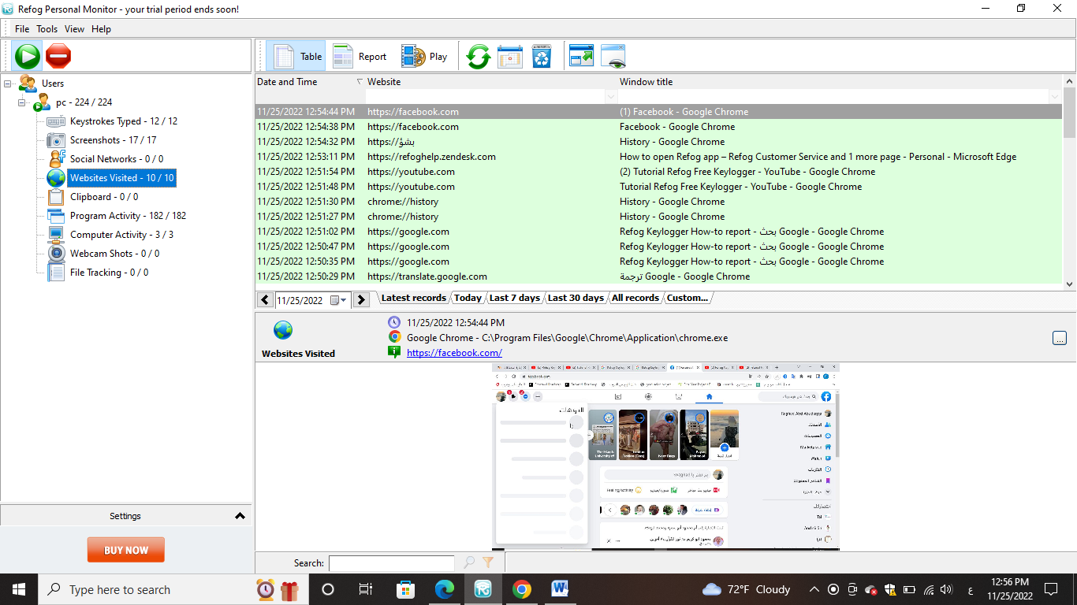

List of all websites visited by the user during the monitoring process

1. **Clipboard** "Everything you type on a keyboard"? What about "everything you paste from the clipboard"? While there is no word for "cliplogger", most keyloggers do in fact monitor the system’s clipboard as well. Everything you place in the clipboard and everything you paste in an app is recorded along with "everything you type”.

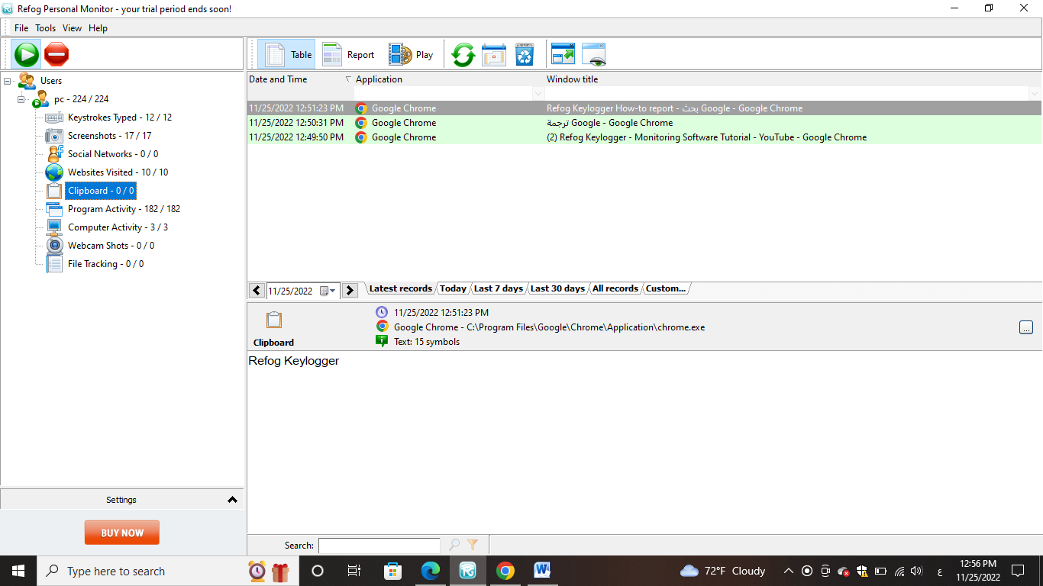

1. **Application monitoring** feature keeps track of all the applications and programs executed by the user on your PC. So you can easily know if your children open any program that is not intended for them.

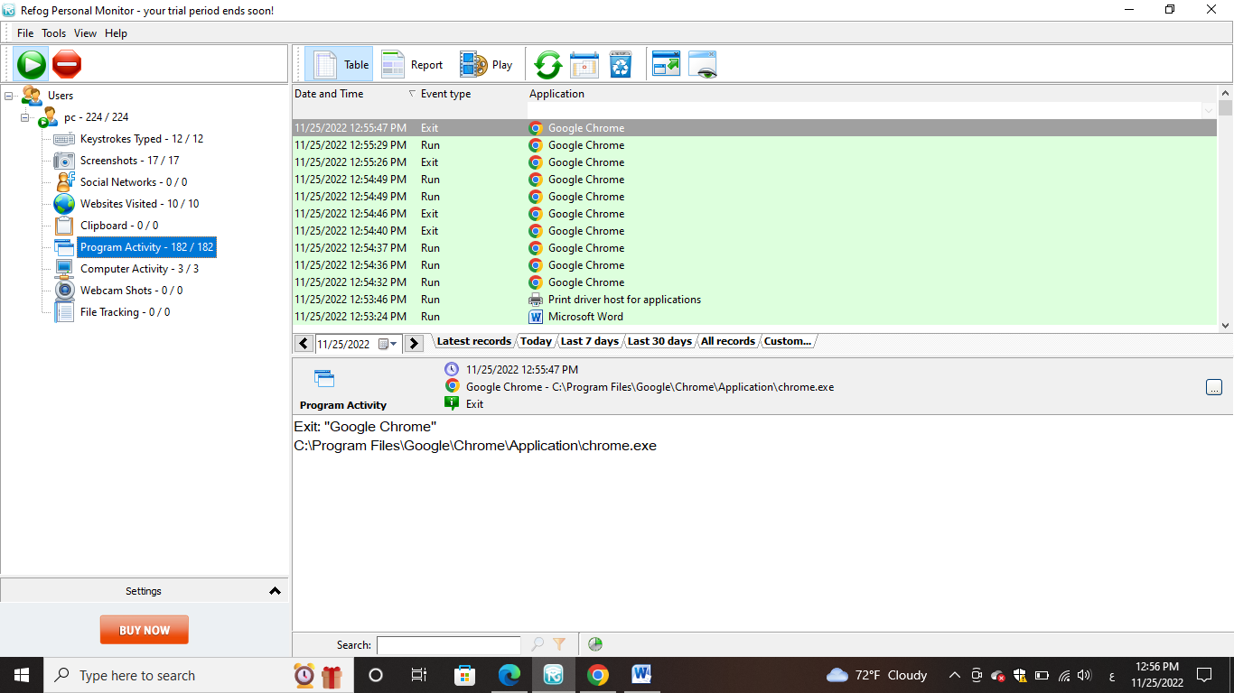

1. **Computer Activity**

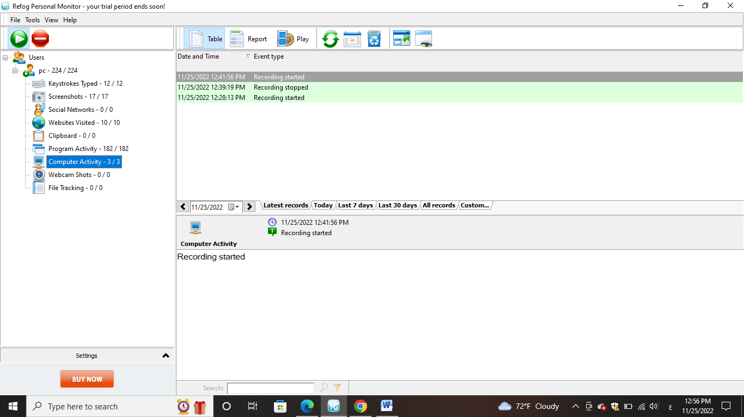

1. **Webcam Shots** It activates the computer’s webcam and takes a picture, so you can see who is using it, and what they’re doing.

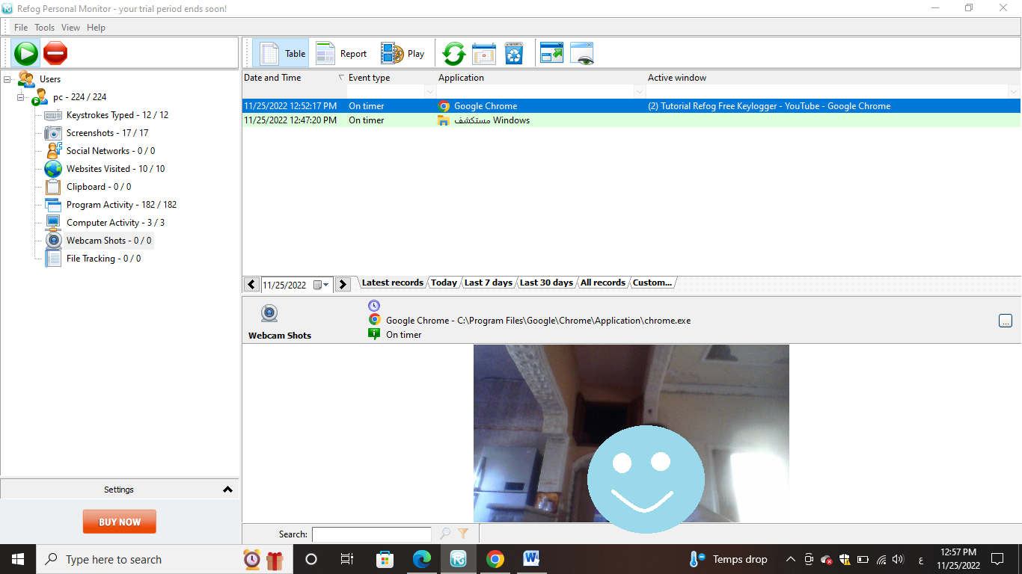

1. **File tracking** feature tracks all the files accessed and file operations like open, edit, copy, paste performed on each and every single file present on your PC. So you can easily find if your user accesses any confidential file that is restricted for them.

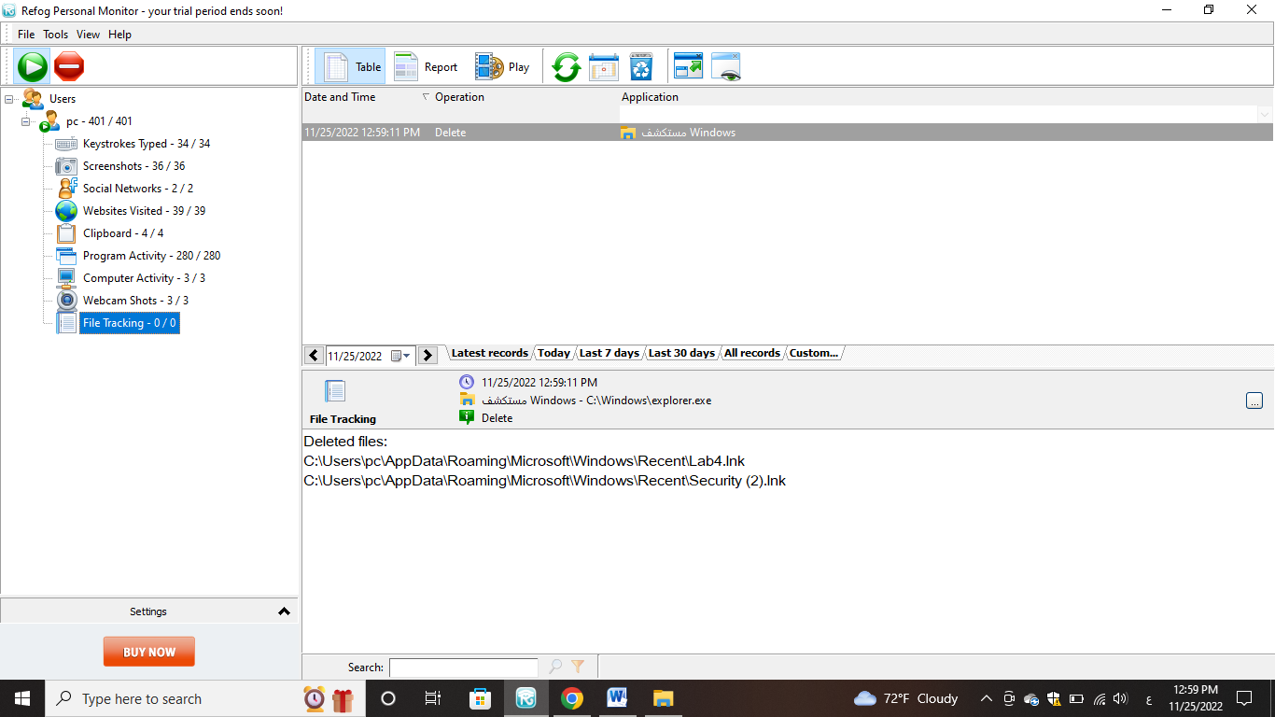

1. **Capture chats and IM** feature can capture all the chats both outgoing and incoming made your children on your PC. So you get to know with whom your children converse and you can control them.
2. The **stealth mode** can allow the software to run completely in invisible mode on your PC so that the user or anyone who is using your computer cannot detect the presence of the software.
3. Real-Time Remote Monitoring
4. **Monitor settings**
5. **Logging Settings**

On this page, you can set logging settings for each user,

activate or deactivate by selecting and canceling them

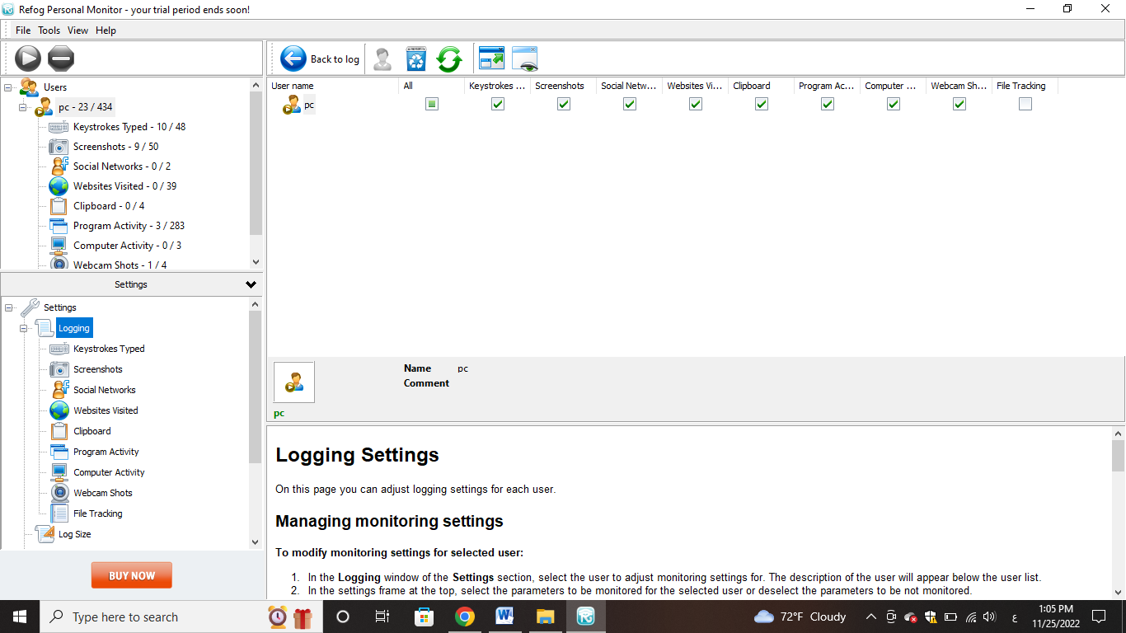

1. 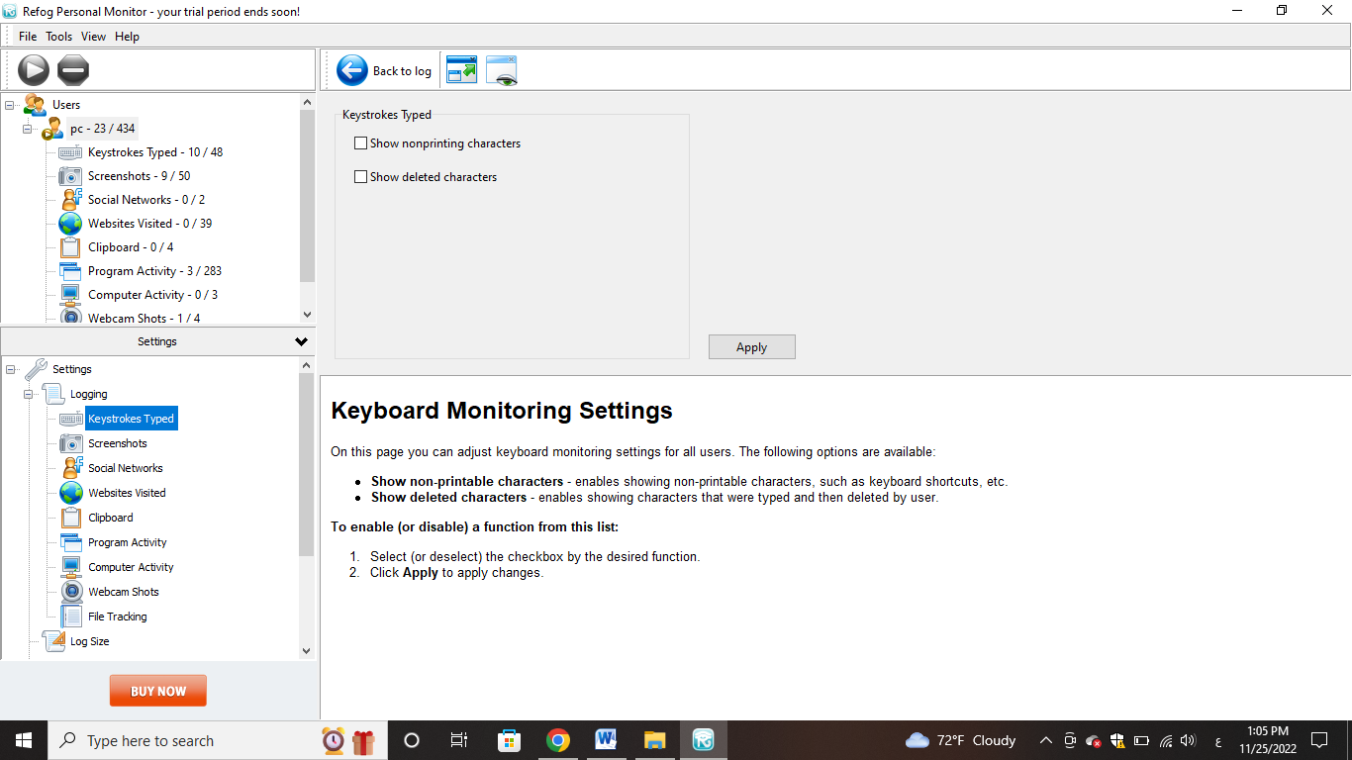**Keyboard Monitoring**
2. **Screenshots**

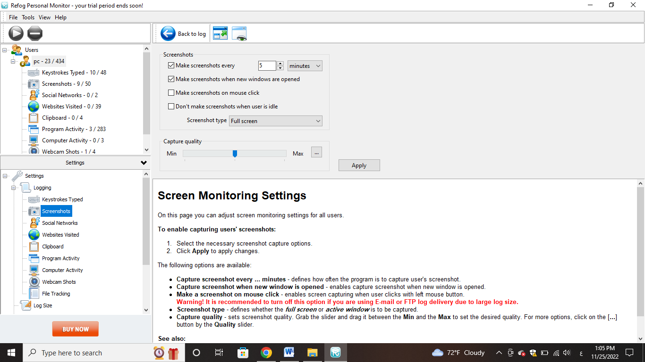

1. **Social Network**

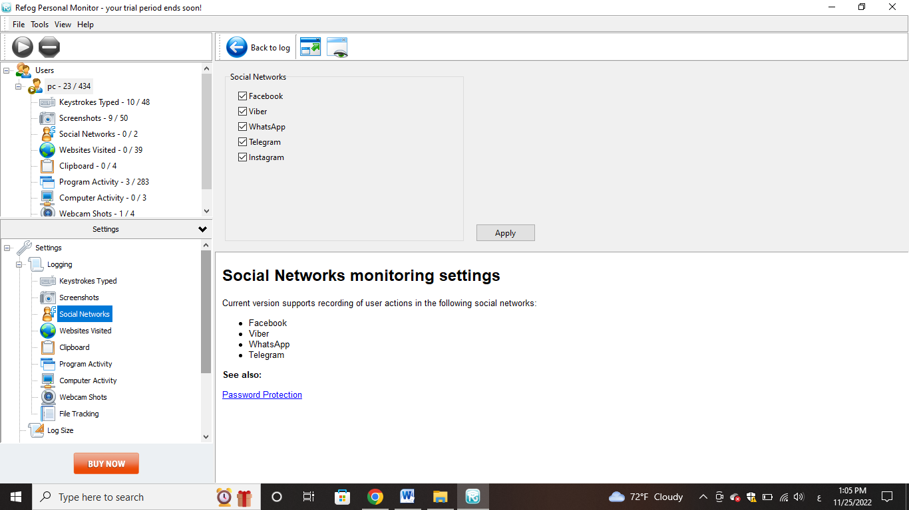

1. 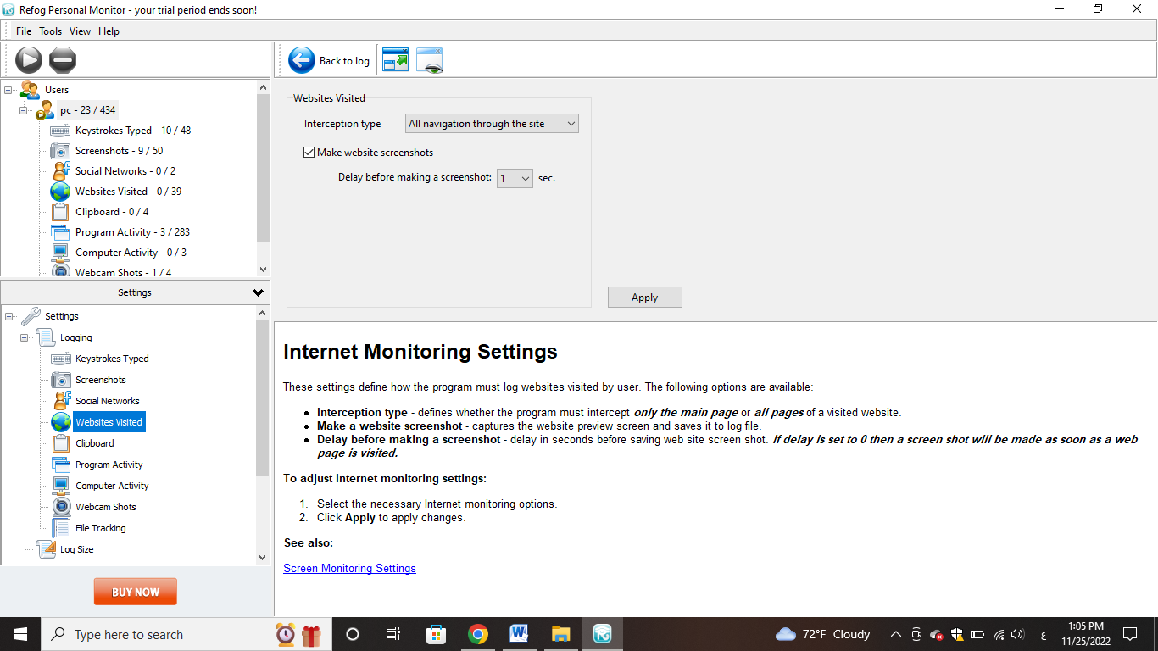**Websites visited**
2. **Clipboard**

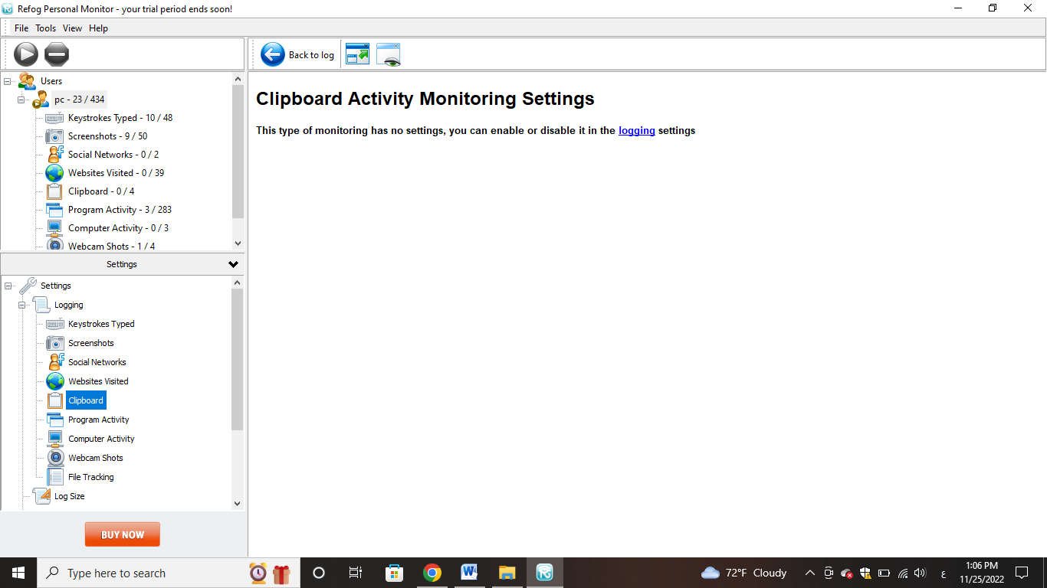

1. **Program Activity**

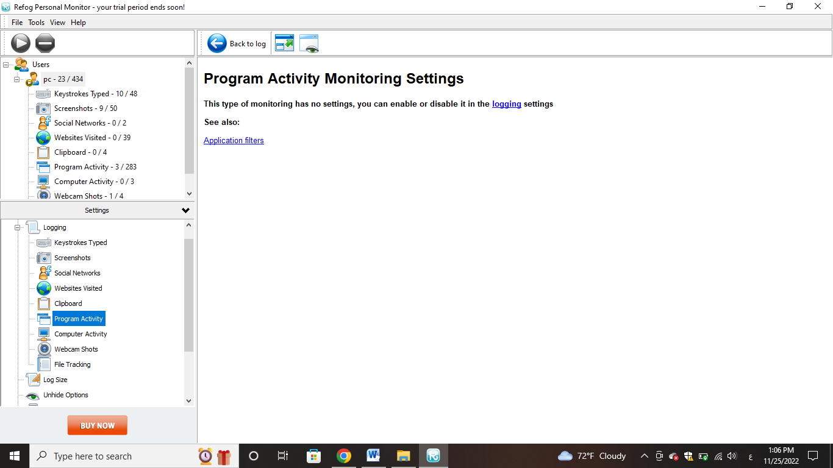

1. 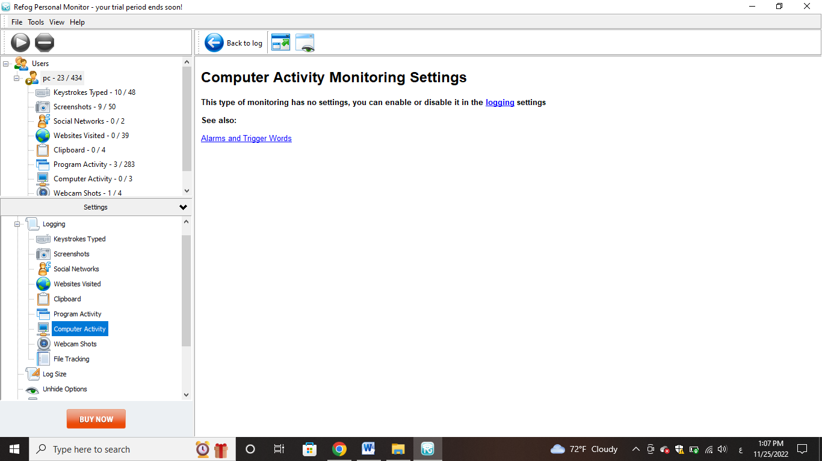**Computer Activity**
2. 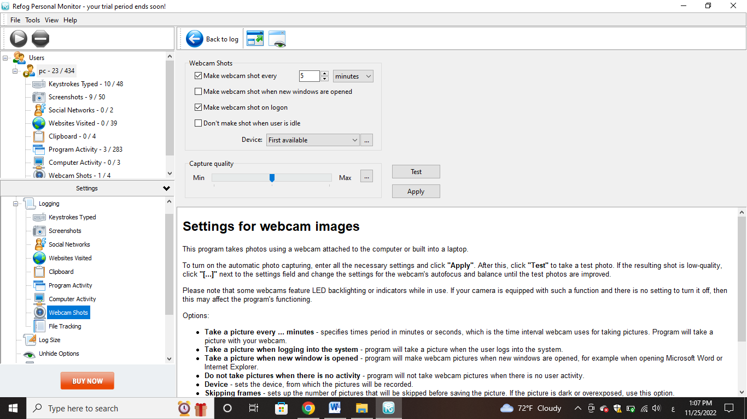**Webcam Shots**
3. **File Tracking**

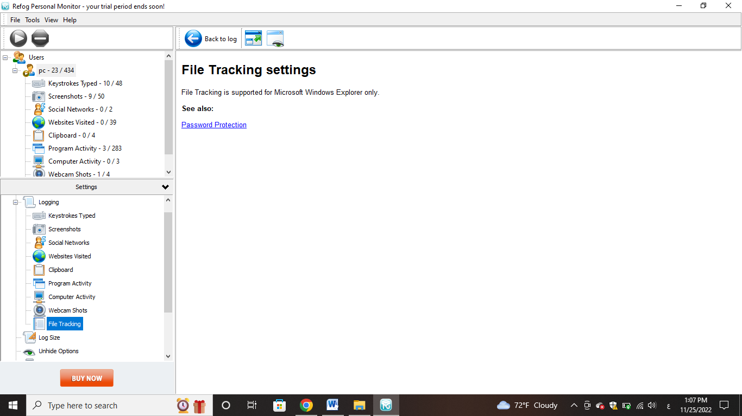

1. 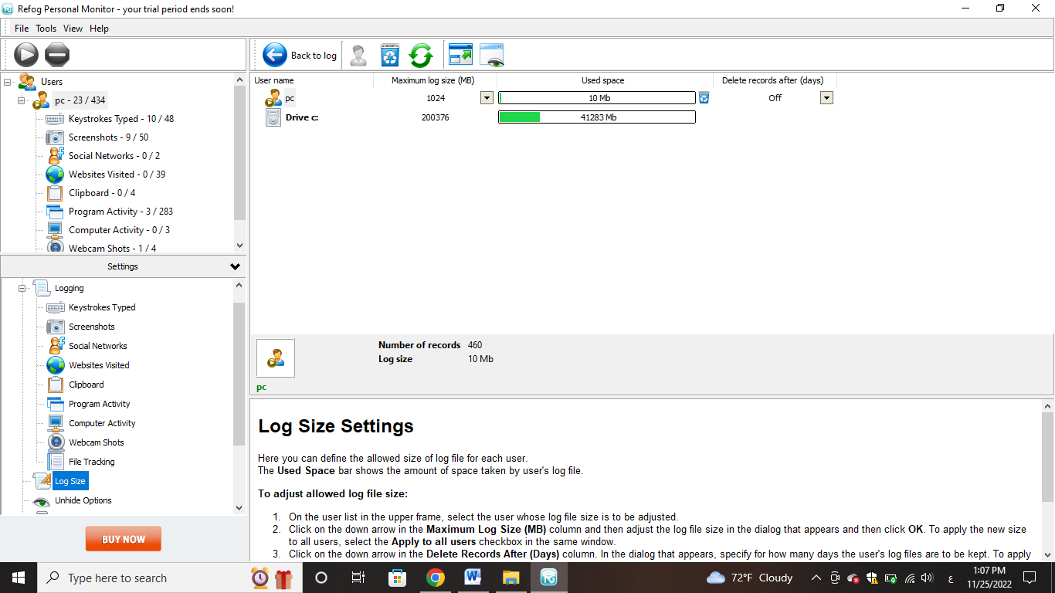**Log Size**

* 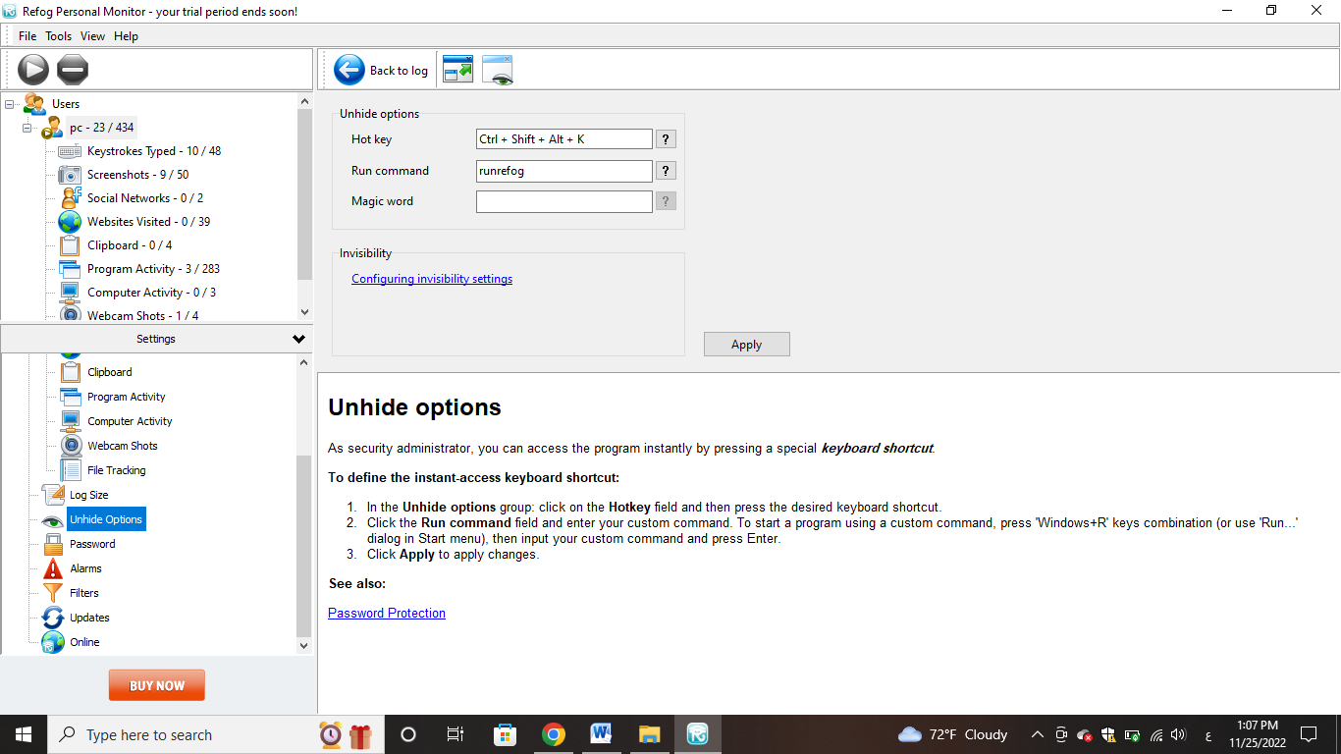**Hide and show the application**
* **Change Password**

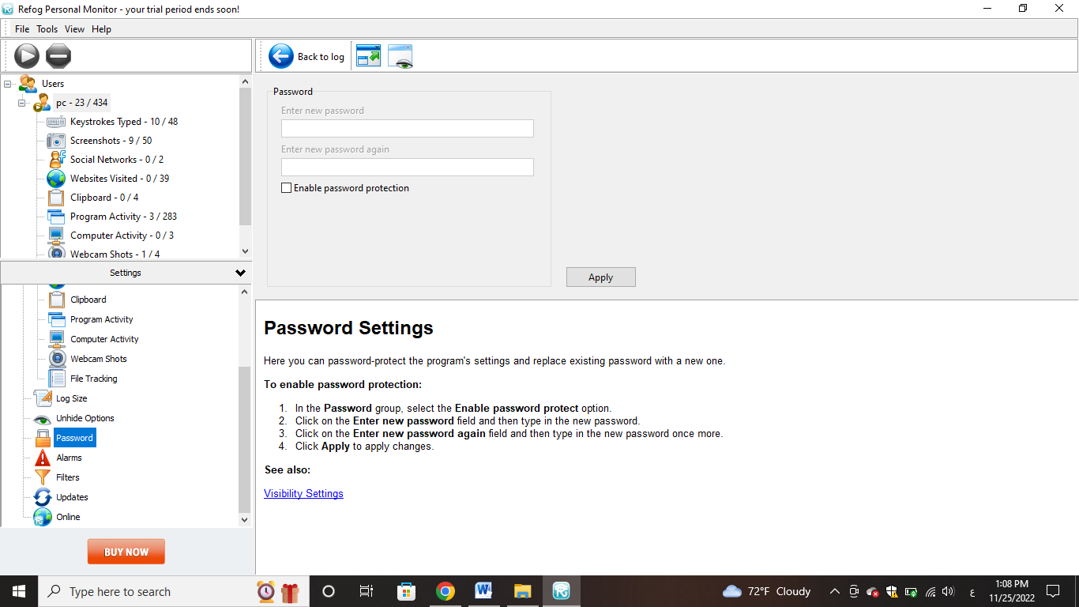

* **Application Alerts**

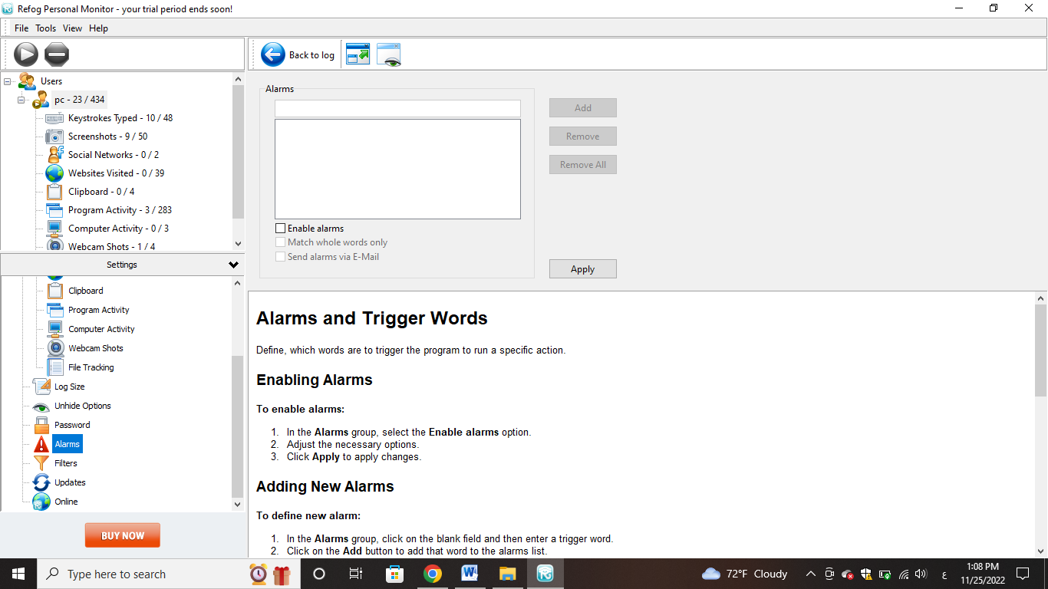

* **Change The Application Language**

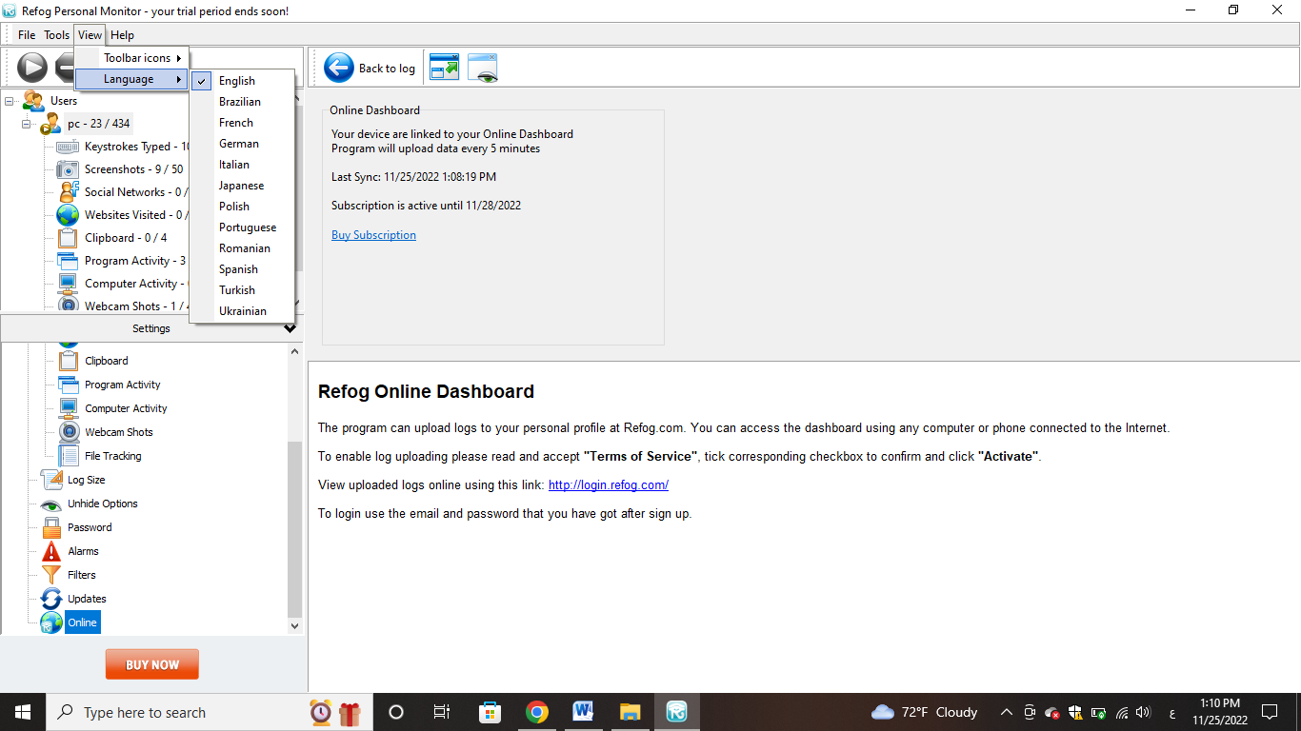

* **The Size Of The Application Icons Is Large Or Small**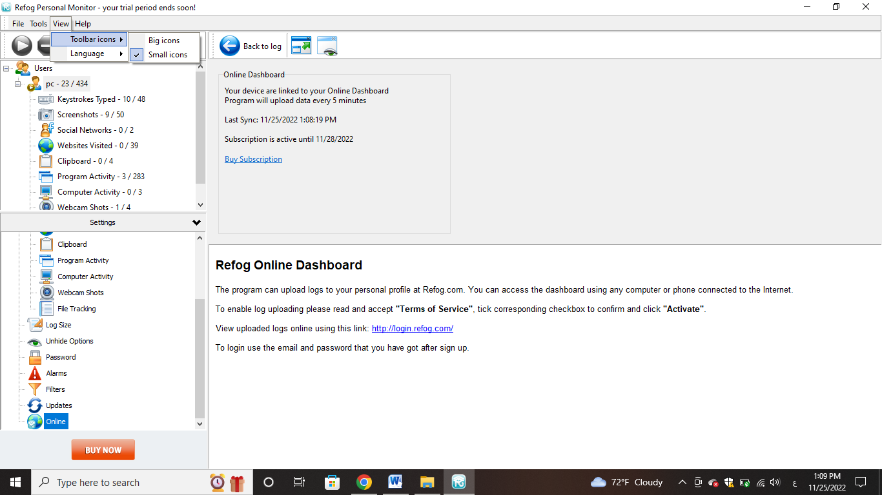
* **Uninstall The App & application settings**

